**IE 260 CLASS EXERCISES - WEEK 2**

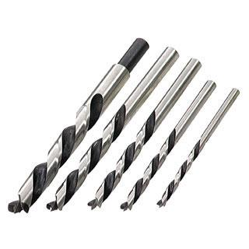1-) During your first month as an employee at Greenfield Industries (a large drill-bit manufacturer), you are asked to evaluate alternatives for producing a newly designed drill bit on a turning machine. Your boss’ memorandum to you has practically no information about what the alternatives are and what criteria should be used. The same task was posed to a previous employee who could not finish the analysis, but she has given you the following information: An old turning machine valued at $350,000 exists (in the warehouse) that can be modified for the new drill bit. The in-house technicians have given an estimate of $40,000 to modify this machine, and they assure you that they will have the machine ready before the projected start date (although they have never done any modifications of this type). It is hoped that the old turning machine will be able to meet production requirements at full capacity. An outside company, McDonald Inc., made the machine seven years ago and can easily do the same modifications for $60,000. The cooling system used for this machine is not environmentally safe and would require some disposal costs. McDonald Inc. has offered to build a new turning machine with more environmental safeguards and higher capacity for a price of $450,000. McDonald Inc. has promised this machine before the startup date and is willing to pay any late costs. Your company has $100,000 set aside for the start-up of the new product line of drill bits. For this situation, apply the engineering economics analysis procedure;

1. Define the problem.
2. List key assumptions.
3. List alternatives facing Greenfield Industries.
4. Select a criterion for evaluation of alternatives.
5. Introduce risk into this situation.
6. Discuss how nonmonetary considerations may impact the selection.
7. Describe how a post audit could be performed.

2-) While studying for the engineering economy final exam, you and two friends find yourselves craving a fresh pizza. You can’t spare the time to pick up the pizza and must have it delivered. “Pick-Up-Sticks”offers a 1-1/4-cm-thick (including toppings), 20-cm **square** pizza with your choice of two toppings for $15 plus 5% sales tax and a $1.50 delivery charge (no sales tax on delivery charge). “Fred’s” offers the round, deep-dish Sasquatch, which is 20 cm in diameter. It is 1-3/4 cm thick, includes two toppings, and costs $17.25 plus 5% sales tax and free delivery.

1. What is the problem in this situation? Please state it in an explicit and precise manner.
2. Systematically apply the seven principles of engineering economy to the problem you have defined in Part (a).
3. Assuming that your common unit of measure is dollars (i.e., cost), what is the better value for getting a pizza based on the criterion of minimizing cost per unit of volume?
4. What other criteria might be used to select which pizza to purchase?